What is Linux?
Linux is a computer operating system, like Microsoft Windows or Apple Mac, but a big difference is that Microsoft Windows and Apple Mac OSX are proprietary, closed source software which you have to pay money to use, whereas Linux is Free Open Source Software (FOSS). So anyone can read, use, change, and run the Linux program code. This gives users of Linux many choices!
Information from The Linux Foundation website (http://www.linuxfoundation.org/):
Linux powers 94% of the world’s supercomputers, most of the servers powering the Internet, the majority of financial trades worldwide and a billion Android devices. In short, Linux is everywhere. It appears in many different architectures, from mainframes to server to desktop to mobile and on a staggeringly wide variety of hardware.
Moreover, 97 percent of hiring managers reported that they will prioritize hiring Linux talent relative to other skills areas in the next six months, and 44 percent of hiring managers saying they’re more likely to hire a candidate with Linux certification.

Basics of Linux User and File Access Permissions
Each Linux user account has a unique UID number and USERNAME. Each user can be a member of one or more GROUPS. Most users can only access or modify specific areas or files within the computer. The SUPERUSER (ROOT) account has full access to the entire Linux system and all files stored within it.
Common commands for administrating users and groups (most require root/sudo access):
adduser (or useradd), addgroup (or groupadd), usermod, groupmod, newgrp, passwd, su

Each file or directory on a Linux system is OWNED by a USER and a GROUP and has a set of access permission bits associated with it (known as the file's MODE). Each file or directory contains READ, WRITE, and EXECUTE (rwx) permissions for its owned user, owned group, and any other user on the Linux system. Each has three extra permission bits: Set User ID (SUID), Set Group ID (SGID), and Sticky Bit (T), which affect how users can access the file or directory.
Common commands for changing ownership and permissions (mode) on a file or directory:
chown, chmod (using octal numeric or symbolic syntax), chattr, umask

Visual breakdown of displayed file permissions when using ls -l
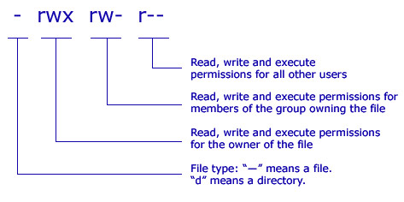

For further information, on Linux File Permissions see Tutonics tutorial: http://www.tutonics.com/2012/12/linux-file-permissions-chmod-umask.html
EXTRA HELP: Linux File Permissions Cheat Sheet

Octal Numerical Syntax for chmod command:
(http://sharemyweb.com/linux-file-permissions-table/)
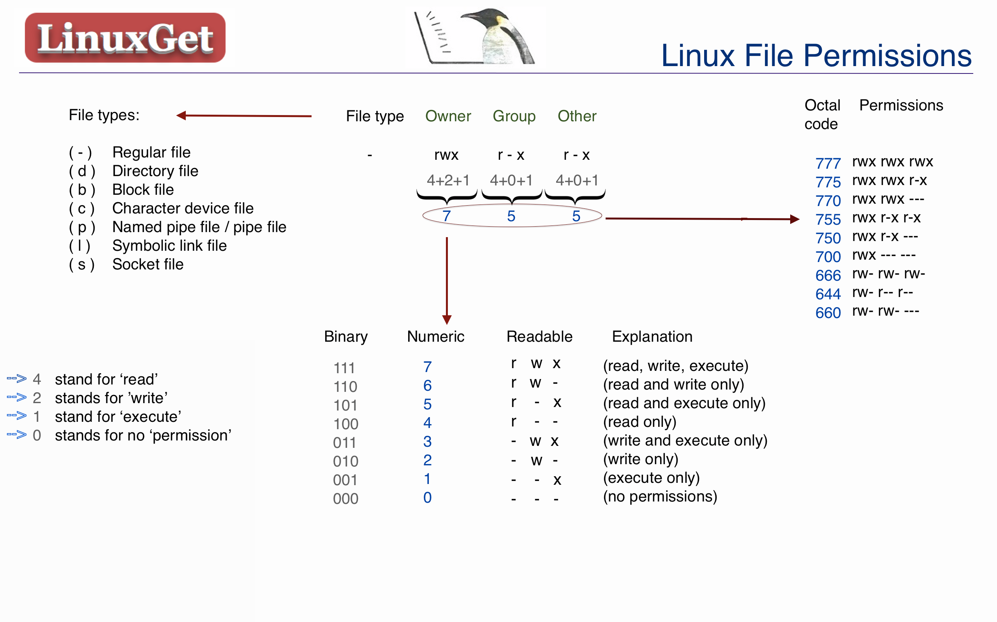

EXAMPLE: chmod 755 my_file
my_file will be set to have permissions of (-rwxr-xr-x).

Symbolic Syntax for chmod command:

The following letters and symbols represent
u user/owner of file or directory
g group owner of file or directory
o all other users on the Linux system
a for all: user/owner, group owner and all other users

r read permission
w write permission
x execute permission

= permissions for u,g, o, or a will be set equal to the specified value of r,w, or x
- specified value of r, w, or x will be removed from the permissions for u,g, o, or a
+ specified value of r, w, or x will be added to the permissions for u,g, o, or a

EXAMPLE: chmod u+w,o=r my_file
my_file will be set with the user (or owner) of the file write permission added (turned on), and other users will only have read permission (but not write or execute permissions). All other permissions of my_file will not change from their previous state.

